NEXTAG COMPANY

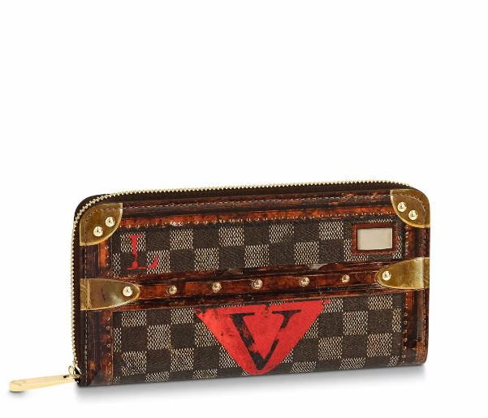LOUIS VUITTON - ZIPPY WALLET

##### **Detail**

The Time Trunk Zippy wallet comes in transformed Damier canvas with trompe-l'œil detailing for a vintage look. It is part of a seasonal collection referencing the Fall-Winter 2018-19 fashion show, where Nicolas Ghesquière revisited Louis Vuitton's historic trunks. This iconic wallet packs a host of convenient features into a secure, zip-around format.

• Transformed Damier canvas

• Calf-leather trim

• Calfskin lining

• Brushed gold-color hardware

• 12 CC slots

##### • 19.5 x 10.5 x 2.5 cm (Length x Height x Width)

##### **CARE & COMPOSITION**

* leather
* imported